https://abap4tod.blogspot.com/2017/03/asd-as-two-alvs-in-single-screen-ekko.html

SE80 – CRIAR UM PROGRAMA (REPORT)
BOTAO DIREITO EM CIMA DO NOME DO PROGRAMA – CRIAR - TELA

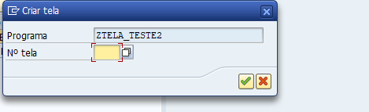
NUMERO DE TELA - 0100
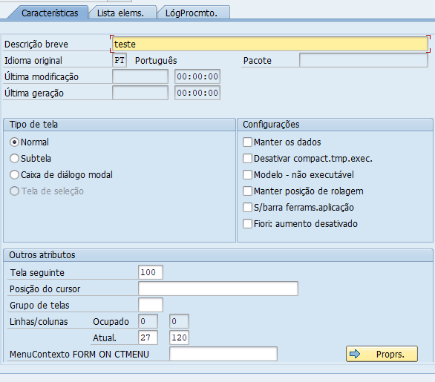

*&---------------------------------------------------------------------*
*& PoolMóds. ZTELA_TESTE
*&---------------------------------------------------------------------*
*&
*&---------------------------------------------------------------------*
REPORT ZTELA_TESTE.
CLASS lcl_event_receiver DEFINITION DEFERRED.
TYPES: BEGIN OF gty_ekko,
ebeln TYPE ebeln,
bukrs TYPE bukrs,
bstyp TYPE ebstyp,
bsart TYPE esart,
bsakz TYPE bsakz,
END OF gty_ekko.
TYPES: BEGIN OF gty_ekpo,
ebeln TYPE ebeln,
ebelp TYPE ebelp,
loekz TYPE eloek,
statu TYPE astat,
aedat TYPE paedt,
END OF gty_ekpo.
DATA: go_grid_1 TYPE REF TO cl_gui_alv_grid,
go_grid_2 TYPE REF TO cl_gui_alv_grid,
go_cont_1 TYPE REF TO cl_gui_custom_container,
go_cont_2 TYPE REF TO cl_gui_custom_container,
gt_ekko TYPE TABLE OF gty_ekko,
gs_ekko TYPE gty_ekko,
gt_ekpo TYPE TABLE OF gty_ekpo,
gs_ekpo TYPE gty_ekpo,
go_event_receiver TYPE REF TO lcl_event_receiver.
START-OF-SELECTION.
CALL SCREEN 0100.
*&---------------------------------------------------------------------*
*& Form CREATE_GRID
*&---------------------------------------------------------------------*
* CRIA DOIS CONTÊINERES E SUAS GRADES CORRESPONDENTES
*----------------------------------------------------------------------*
FORM create_grid.
CREATE OBJECT go_cont_1 "CONTAINER 1
EXPORTING
container_name = 'CUST_CONT_1'.
CREATE OBJECT go_grid_1 "GRID 1
EXPORTING
i_parent = go_cont_1.
CREATE OBJECT go_cont_2 "CONTAINER 2
EXPORTING
container_name = 'CUST_CONT_2'.
CREATE OBJECT go_grid_2 "GRID 2
EXPORTING
i_parent = go_cont_2.
ENDFORM. " CREATE_GRID
*&---------------------------------------------------------------------*
*& Form DISPLAY_GRID
*&---------------------------------------------------------------------*
* EXIBIR GRADE 1 - GRADE DA ESQUERDA
*----------------------------------------------------------------------*
FORM display_grid1 .
*Cria um botao a esquerda para escolha multipla
DATA: ls_layout TYPE lvc_s_layo.
*tipo da escolha multipla
ls_layout-sel_mode = 'D'.
CALL METHOD go_grid_1->set_table_for_first_display
EXPORTING
i_structure_name = 'EKKO'
is_layout = ls_layout " Adicione esta linha
CHANGING
it_outtab = gt_ekko
EXCEPTIONS
invalid_parameter_combination = 1
program_error = 2
too_many_lines = 3
OTHERS = 4.
ENDFORM. " DISPLAY_GRID
*&---------------------------------------------------------------------*
*& Form DISPLAY_GRID
*&---------------------------------------------------------------------*
* EXIBIR GRADE 2 - GRADE DA DIREITA
*----------------------------------------------------------------------*
FORM display_grid2 .
CALL METHOD go_grid_2->set_table_for_first_display
EXPORTING
i_structure_name = 'EKPO'
CHANGING
it_outtab = gt_ekpo
EXCEPTIONS
invalid_parameter_combination = 1
program_error = 2
too_many_lines = 3
OTHERS = 4.
ENDFORM. " DISPLAY_GRID
*&---------------------------------------------------------------------*
*& Form GET_DATA
*&---------------------------------------------------------------------*
* BUSCAR DADOS DA TABELA DE CABEÇALHO 'EKKO'
*----------------------------------------------------------------------*
FORM get_data_ekko .
SELECT ebeln
bukrs
bstyp
bsart
bsakz
FROM ekko
INTO TABLE gt_ekko
UP TO 20 ROWS.
ENDFORM. " GET_DATA
*----------------------------------------------------------------------*
* CLASS lcl_event_receiver DEFINITION
*----------------------------------------------------------------------*
* DEFINIÇÃO DA CLASSE PARA TRATAR O EVENTO ALV - CLIQUE DUPLO
*----------------------------------------------------------------------*
CLASS lcl_event_receiver DEFINITION.
PUBLIC SECTION.
METHODS:
handle_double_click
FOR EVENT double_click OF cl_gui_alv_grid
IMPORTING e_row
e_column.
ENDCLASS. "lcl_event_receiver DEFINITION
*----------------------------------------------------------------------*
* CLASS lcl_event_receiver IMPLEMENTATION
*----------------------------------------------------------------------*
* IMPLEMENTAÇÃO DA CLASSE PARA TRATAR O EVENTO ALV - CLIQUE DUPLO
*----------------------------------------------------------------------*
CLASS lcl_event_receiver IMPLEMENTATION.
METHOD handle_double_click.
READ TABLE gt_ekko INTO gs_ekko INDEX e_row-index.
IF sy-subrc EQ 0.
SELECT ebeln
ebelp
loekz
statu
aedat
FROM ekpo
INTO TABLE gt_ekpo
WHERE ebeln = gs_ekko-ebeln.
IF sy-subrc EQ 0.
PERFORM display_grid2.
ENDIF.
ENDIF.
ENDMETHOD. "handle_double_click
ENDCLASS. "lcl_event_receiver IMPLEMENTATION
*&---------------------------------------------------------------------*
*& Module STATUS_0100 OUTPUT
*&---------------------------------------------------------------------*
* EVENTO PBO DA TELA
*----------------------------------------------------------------------*
MODULE status_0100 OUTPUT.
SET PF-STATUS 'PF_STATUS'.
IF go_cont_1 IS INITIAL AND go_cont_2 IS INITIAL.
PERFORM get_data_ekko.
PERFORM create_grid.
CREATE OBJECT go_event_receiver.
SET HANDLER go_event_receiver->handle_double_click FOR go_grid_1.
PERFORM display_grid1.
ENDIF.
ENDMODULE. " STATUS_0100 OUTPUT
*&---------------------------------------------------------------------*
*& Module USER_COMMAND_0100 INPUT
*&---------------------------------------------------------------------*
* PAI EVENT OF THE SCREEN
*----------------------------------------------------------------------*
MODULE user_command_0100 INPUT.
CASE sy-ucomm.
WHEN '&F03' OR 'BACK' OR 'BCK' OR '&F15' OR '&F12' .
LEAVE TO SCREEN 0.
ENDCASE.
ENDMODULE. " USER_COMMAND_0100 INPUT

